SOFTWARE REQUIREMENT SPECIFICATION
CARDZO
DOCUMENT SCANNER APP

Submitted By

Sidarth CS
Praveen Kumar T
Krishnendu Suresh
Jyothis KS
Jabirhusain KP

On

22 - SEPTEMBER – 2020

TABLE OF CONTENTS

- Introduction
1.1 Purpose
1.2 Document Conventions
1.3 Scope
1.4 Need For The System
1.5 References

- Overall Description
2.1 Product Perspectives
2.2 Product Features
2.3 User Classes And Charecteristics
2.4 Design and Implementation Constraints
2.5 Dependancies

- System Features
3.1 Functional Requirements

- External Interface Requirements
4.1 User Interfaces
4.2 Hardware Interfaces
4.3 Software Interfaces
4.4 Communications Interfaces

- Non Functional Requirements
5.1 Perfomance Requirements
5.2 Security and Privacy Requirements
5.3 Software Quality Attributes

1. Introduction

1.1 Purpose

The purpose of this Systems Requirements Specifications document (therefore referred to as SRS) is to provide the guidelines necessary to design and implement software that fulfills all the requirements given.

In the case of our document scanner application (simply referred to as CARDZO ), this document will contain enough information so that in the event that the current team is not able to complete the software, a future team can use this document and only this document to create another version of the software that still fulfills all the requirements.

1.2 Document Conventions

This Document was created based on the IEEE template for System Requirement
Specification Documents.

- Glossary
  - RAM – Random Access Memory
  - UI – User Interface
  - SDK – Software Development Kit
  - App – Application
  - User – Person Who Uses The Application

1.3 Scope

The app is intended to provide the users with a stable platform for storing their valuable documents in digital format. Cardzo app will help them to scan every document, and store it’s digital copy on their android smartphone.

1.4 Need For The System

- There are a few apps which helps to scan the documents. However , users need a simple application to scan and store their valuable documents in a secure way.
- With a simple UI and omitting the non-essential features , we can make the app convenient to use.
- Also, Cardzo app stores the documents in local storage in a secured format.

1.5 References

- https://www.perforce.com/blog/alm/how-write-software-requirements-specification-srs-document

- https://apro-software.com/writing-specifications-for-a-mobile-app-development-project/

- https://www.geeksforgeeks.org/how-to-write-a-good-srs-for-your-project/

2. Overall Description

2.1 Product Perspective

The Cardzo app will ensure all the documents and user details are stored in the local database, and makes the retreival of information or any documents possible. Even though there are some applications in the market with same functionalities, the complex UI and non-essential features makes the apps pretty cumbersome to use . Here, through Cardzo app, with the simplest user interface and essential features will make the user’s life easier.

2.2 Product Features

- Set Up Profile – User need to set up a profile before start using the app.
- List Documents – There will be a list, in which user can view the scanned documents.
- Scan Document – User can a document when ever they want.
- Add Document – User can add documents from a photographs , which are already in the gallery.
- Share Documents – User can share the documents to other app or save it to a file.

2.3 User Characteristics

- Types Of Users :
  - Android Smartphone Users

- Technical Expertise :
  - Users needs to have minimal knowladge of using smartphones and smartphone camera.

2.4 Design And Implementation Constraints

- Platform :
  - Should work on Android Phones.

- Operating System :
  - Android – Version 6.0 above ( API 23 above )

- Hardware :
  - Smartphone should have camera
  - at least 2GB RAM

2.5 Dependancies

- Our app makes use of a plug in ( Scanbot SDK flutter Plug-In)

3. System Features

3.1 Functional Requirements

- Application will be initialized with user details.

  - Description : The basic details about the user is collected and stored in the database.

  - Implementation : A UI with a simple form is launched on first launch.Then takes user inputs.

  - Criticality : This is crucial. Because user is the heart of our application.

  - Risks : The user may enter invalid data.

  - Dependancy : Relies on information from user.

- Application will be able to retreive previously scanned documents.

  - Description : Shows a list of documents, which are already scannedand stored by the user.

  - Implementation : UI with a list of names and thumbnails, in which user can select a document.

  - Criticality : The main functionality of our app is storage and retreival of documents.

  - Risks : The documents should be sorted according to the user’s preference.

  - Dependancy : Depends on the local database by the app.

- Application will be able to scan documents

  - Description : Using camera, the app will capture the photo of document and process the document to digital format.

  - Implementation : Using scanbot SDK, there will be a frame for showing the camera visuals in real-time and a button to initiate scanning .

  - Criticality : Crucial. The user must be able to add new documents to database.

  - Risks : Since, we rely upon an external plugin , there might be chances of unexpected behaviours.

  - Dependancy : Depends upon the Scanbot SDK flutter plug-in

- Application will be able to display the documents

  - Description : User can view the scanned document inside the application.

  - Implementation : A full screen UI with some buttons for navigation. The document will be displayed in a frame.

  - Criticality : Crucial. User should be able to view the documents.

  - Risks : There may be problem with data unavailabilty, due to the formatting or deleting of files.

  - Dependancy : Depends upon device local storage.

- Application will be able to add pre-captured photos from gallery app.

  - Description : The application can scan and add documents to app from the photographs that are available in the device.

  - Implementation : User should select the photo and the scanning and processing of document is done. Then it will be added to the app and stored in device.

  - Criticality : Required. Sometimes user may have old photos of documents. In that case, user can add the photos into app.

  - Risks : The photo format must be supported by app.

  - Dependancy : Relies upon gallery app of android device.

- Application will allow user to control the documents.

  - Description : The user can rename and delete documents if they wish to do so. Also , they can organize the documents.

  - Implementation : User can select a document and there will be a menu with the options for deletion and renaming.

  - Criticality : Crucial. Users may need to organize or delete or rename the documents as they wish.

  - Risks : There may be an accidental operation.

  - Dependancy : Relies upon user inputs.

4. External Interface Requirements

4.1 User Interfaces

- Main Activity

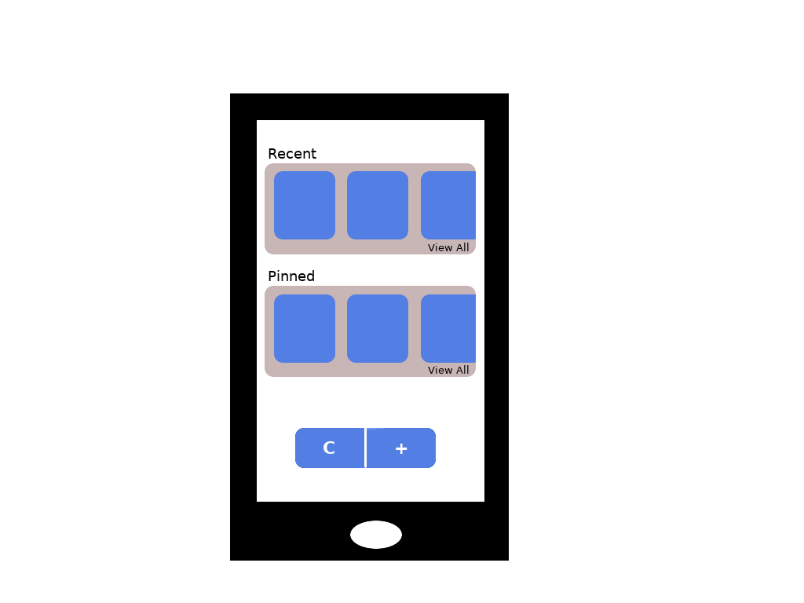
  - Recent : Shows the documents scanned recently

  - Pinned : Shows the user pinned documents

  - Scan Button : Goes to scanner activity

  - Add Button : Goes to select activity

- Scanner Activity

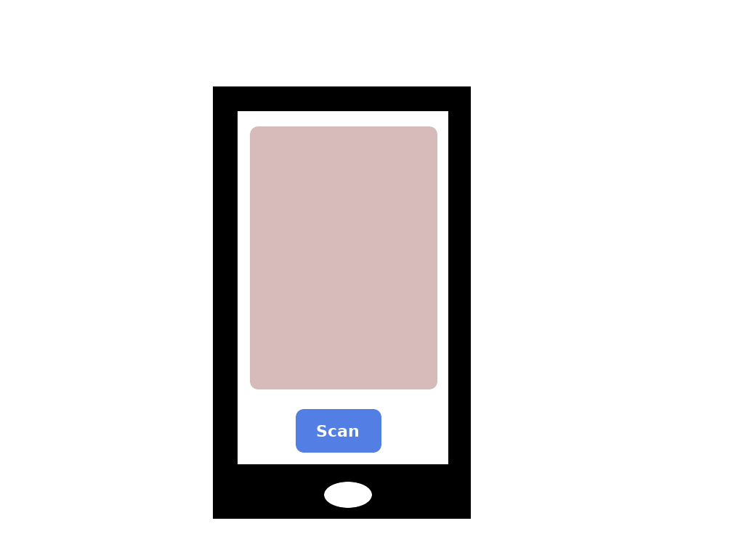

- Scanning Frame : Shows the camera visuals

- Scan Button : Starts the scanning process

- Document Activity

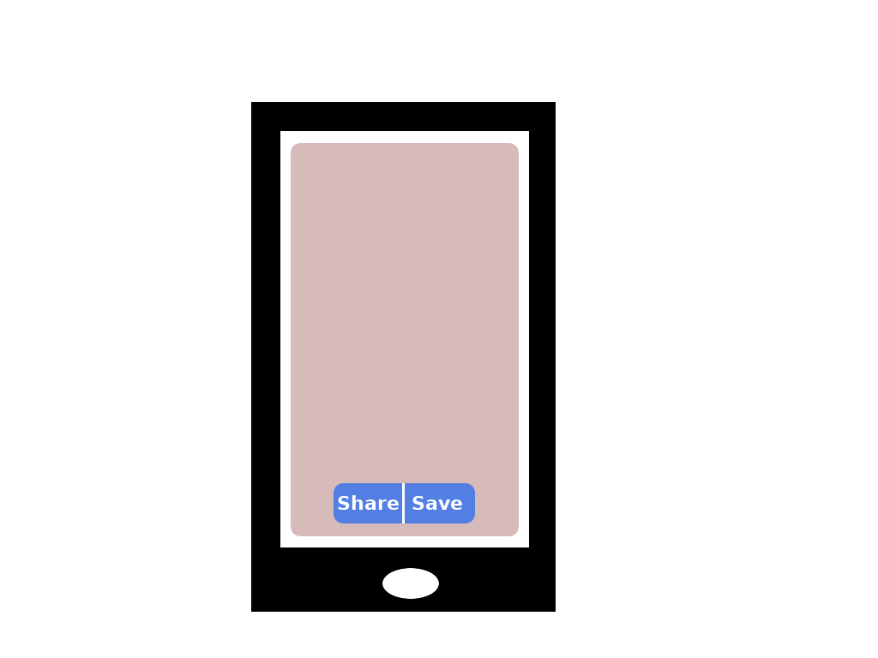

- Document Viewer : Displays the document.

- Toolbar : Tools with different options for sharing , editing and saving the file.

- Selection Activity

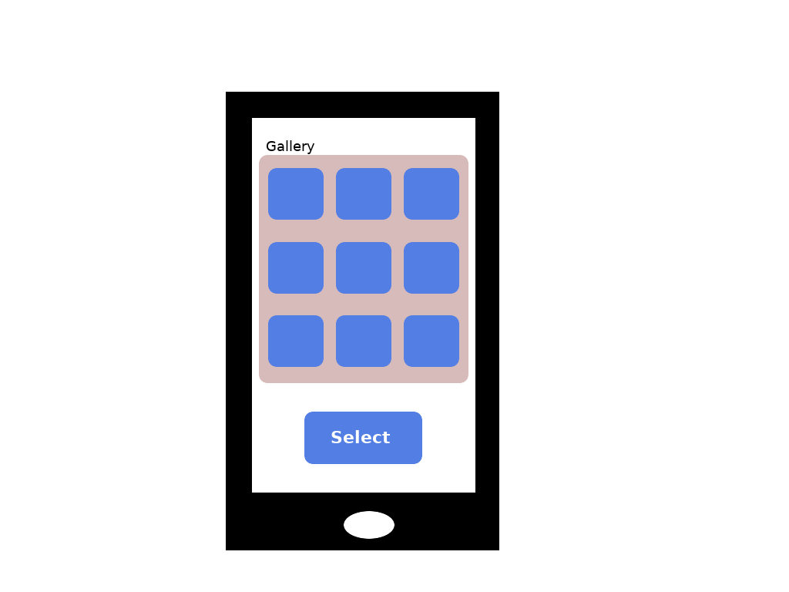

- Gallery : Shows the images from gallery app.

- Select Button : Selects the image for document scanning.

- Process Activity

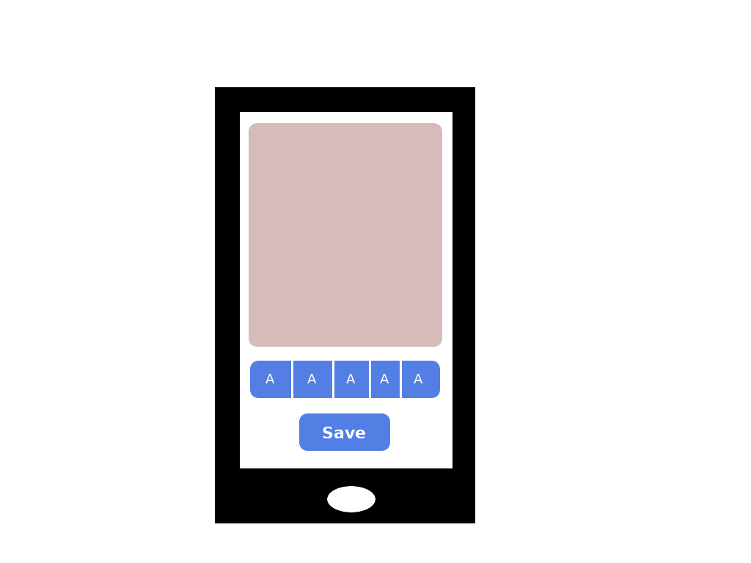

- Document Viewer : Shows the document in frame.

- Toolbar : Tools for enhancement

- Save Button : Saves the documents to local storage.

4.2 Hardware Interfaces

- Smartphone with Android OS
- Camera for capturing the images

4.3 Software Interfaces

- The scanner component will use the plug-in Scanbot SDK
- The gallery app is used for importing documents from existing images in gallery

4.4 Communication Interfaces

- Internet – We need internet to connect with the scanning API.

5. Non Functional Requirements

5.1 Perfomance Requirements

This section describes the expected performance requirements. This is an estimation of the system, and all the numerical values may vary depends on how large the final application is.

- Static Numerical Requirements
  - The application shall support only one simultaneous user on each machine.
  - The application shall run on any android phone with android version 6 or above and with RAM more than 2 GB.

- Dynamic Numerical Requirements
  - The application shall be loaded and functioning within 10 seconds 95% of the time after starting the application.
  - Each Documents shall be processed within 10 seconds 90% of the time after scanning.

5.2 Security and Privacy Requirements

Our application is privacy and security sensitive in nature, specifically with regards to the scanned documents of individuals.

In order to build trust with the users of our system, the system can make use of the following strategies

- Encryption
Each and every document is stored in an encrypted format.

- Giving control of the data to the User
Users can delete the documents from the app whenever they want

5.3 Software Quality Attributes

- Reliability
The system will be able to handle the delays over internet and invalid inputs.

- Security
The system will use device’s default security. Since, storage of user data is done, our application will implement its own security features like encryption.

- Maintainability
The application stores every data in local databases. Each components are mostly modular and independent of others.

